**Week 4**

**Spring REST handson**

**2. spring-rest-handson**

**Hello World RESTful Web Service**   
  
**Write a REST service in the spring learn application created earlier, that returns the text "Hello World!!" using Spring Web Framework.**

**FILE STRUCTURE**

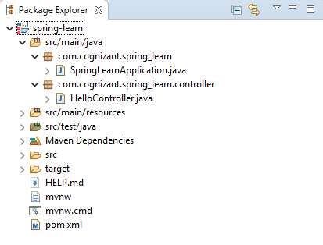

**CODE**

***pom.xml***

<?xml version="1.0" encoding="UTF-8"?>

<project xmlns="http://maven.apache.org/POM/4.0.0" xmlns:xsi="http://www.w3.org/2001/XMLSchema-instance"

    xsi:schemaLocation="http://maven.apache.org/POM/4.0.0 https://maven.apache.org/xsd/maven-4.0.0.xsd">

    <modelVersion>4.0.0</modelVersion>

    <parent>

        <groupId>org.springframework.boot</groupId>

        <artifactId>spring-boot-starter-parent</artifactId>

        <version>3.5.3</version>

        <relativePath/>

    </parent>

    <groupId>com.cognizant</groupId>

    <artifactId>spring-learn</artifactId>

    <version>0.0.1-SNAPSHOT</version>

    <name>spring-learn</name>

    <description>Demo project for Spring Boot</description>

    <url/>

    <licenses>

        <license/>

    </licenses>

    <developers>

        <developer/>

    </developers>

    <scm>

        <connection/>

        <developerConnection/>

        <tag/>

        <url/>

    </scm>

    <properties>

        <java.version>17</java.version>

    </properties>

    <dependencies>

        <dependency>

            <groupId>org.springframework.boot</groupId>

            <artifactId>spring-boot-starter-web</artifactId>

        </dependency>

        <dependency>

            <groupId>org.springframework.boot</groupId>

            <artifactId>spring-boot-devtools</artifactId>

            <scope>runtime</scope>

            <optional>true</optional>

        </dependency>

        <dependency>

            <groupId>org.springframework.boot</groupId>

            <artifactId>spring-boot-starter-test</artifactId>

            <scope>test</scope>

        </dependency>

    </dependencies>

    <build>

        <plugins>

            <plugin>

                <groupId>org.springframework.boot</groupId>

                <artifactId>spring-boot-maven-plugin</artifactId>

            </plugin>

        </plugins>

    </build>

</project>

*src\main\java\com\cognizant\spring_learn\controller\HelloController.java*

package com.cognizant.spring_learn.controller;

import org.slf4j.Logger;

import org.slf4j.LoggerFactory;

import org.springframework.web.bind.annotation.GetMapping;

import org.springframework.web.bind.annotation.RestController;

@RestController

public class HelloController {

    private static final Logger LOGGER = LoggerFactory.getLogger(HelloController.class);

    @GetMapping("/hello")

    public String sayHello() {

        LOGGER.info("START sayHello()");

        String message = "Hello World!!";

        LOGGER.info("END sayHello()");

        return message;

    }

}

*src\main\java\com\cognizant\spring_learn\SpringLearnApplication.java*

package com.cognizant.spring_learn;

import org.slf4j.Logger;

import org.slf4j.LoggerFactory;

import org.springframework.boot.SpringApplication;

import org.springframework.boot.autoconfigure.SpringBootApplication;

@SpringBootApplication

public class SpringLearnApplication {

    private static final Logger LOGGER = LoggerFactory.getLogger(SpringLearnApplication.class);

    public static void main(String[] args) {

        SpringApplication.run(SpringLearnApplication.class, args);

        LOGGER.info("Inside main");

    }

}

**OUTPUT**

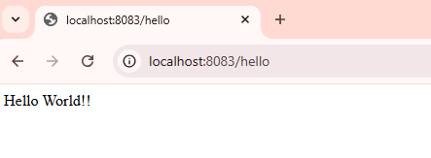

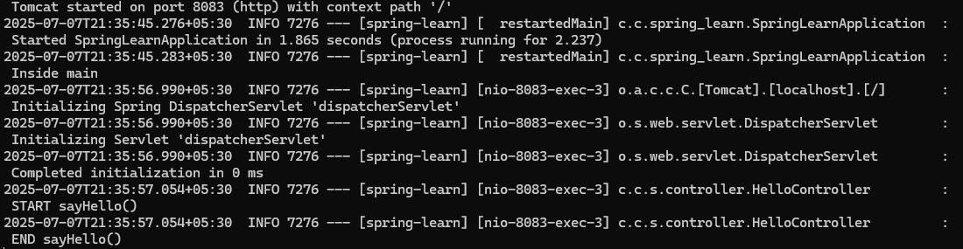

**REST - Country Web Service**   
  
Write a REST service that returns India country details in the earlier created spring learn application.  
  
**URL**: /country  
**Controller**: com.cognizant.spring-learn.controller.CountryController  
**Method Annotation**: @RequestMapping  
**Method Name**: getCountryIndia()  
**Method Implementation**: Load India bean from spring xml configuration and return  
**Sample Request**: http://localhost:8083/country  
**Sample Response**:

{

  "code": "IN",

  "name": "India"

}

**FILE STRUCTURE**

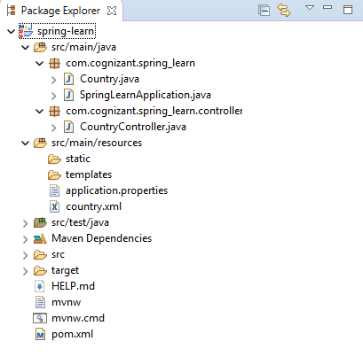

**CODE**

*src\main\java\com\cognizant\spring_learn\controller\CountryController.java*

package com.cognizant.spring_learn.controller;

import org.springframework.web.bind.annotation.RequestMapping;

import org.springframework.web.bind.annotation.RestController;

import org.springframework.context.ApplicationContext;

import org.springframework.context.support.ClassPathXmlApplicationContext;

import com.cognizant.spring_learn.Country;

@RestController

public class CountryController {

    @RequestMapping("/country")

    public Country getCountryIndia() {

        ApplicationContext context = new ClassPathXmlApplicationContext("country.xml");

        Country country = context.getBean("country", Country.class);

        return country;

    }

}

*src\main\java\com\cognizant\spring_learn\Country.java*

package com.cognizant.spring_learn;

public class Country {

    private String code;

    private String name;

    public Country() {

        System.out.println("Inside Country Constructor");

    }

    public String getCode() {

        System.out.println("Inside getCode");

        return code;

    }

    public void setCode(String code) {

        System.out.println("Inside setCode");

        this.code = code;

    }

    public String getName() {

        System.out.println("Inside getName");

        return name;

    }

    public void setName(String name) {

        System.out.println("Inside setName");

        this.name = name;

    }

    @Override

    public String toString() {

        return "Country [code=" + code + ", name=" + name + "]";

    }

}

*src\main\java\com\cognizant\spring_learn\SpringLearnApplication.java*

package com.cognizant.spring_learn;

import org.slf4j.Logger;

import org.slf4j.LoggerFactory;

import org.springframework.boot.SpringApplication;

import org.springframework.boot.autoconfigure.SpringBootApplication;

@SpringBootApplication

public class SpringLearnApplication {

    private static final Logger LOGGER = LoggerFactory.getLogger(SpringLearnApplication.class);

    public static void main(String[] args) {

        SpringApplication.run(SpringLearnApplication.class, args);

        LOGGER.info("Inside main");

    }

}

*src\main\resources\application.properties*

spring.application.name=spring-learn

server.port=8083

*src\main\resources\country.xml*

<beans xmlns="http://www.springframework.org/schema/beans"

       xmlns:xsi="http://www.w3.org/2001/XMLSchema-instance"

       xsi:schemaLocation="http://www.springframework.org/schema/beans

       http://www.springframework.org/schema/beans/spring-beans.xsd">

    <bean id="country" class="com.cognizant.spring_learn.Country">

        <property name="code" value="IN" />

        <property name="name" value="India" />

    </bean>

</beans>

*pom.xml*

<?xml version="1.0" encoding="UTF-8"?>

<project xmlns="http://maven.apache.org/POM/4.0.0" xmlns:xsi="http://www.w3.org/2001/XMLSchema-instance"

    xsi:schemaLocation="http://maven.apache.org/POM/4.0.0 https://maven.apache.org/xsd/maven-4.0.0.xsd">

    <modelVersion>4.0.0</modelVersion>

    <parent>

        <groupId>org.springframework.boot</groupId>

        <artifactId>spring-boot-starter-parent</artifactId>

        <version>3.5.3</version>

        <relativePath/>

    </parent>

    <groupId>com.cognizant</groupId>

    <artifactId>spring-learn</artifactId>

    <version>0.0.1-SNAPSHOT</version>

    <name>spring-learn</name>

    <description>Demo project for Spring Boot</description>

    <url/>

    <licenses>

        <license/>

    </licenses>

    <developers>

        <developer/>

    </developers>

    <scm>

        <connection/>

        <developerConnection/>

        <tag/>

        <url/>

    </scm>

    <properties>

        <java.version>17</java.version>

    </properties>

    <dependencies>

        <dependency>

            <groupId>org.springframework.boot</groupId>

            <artifactId>spring-boot-starter-web</artifactId>

        </dependency>

        <dependency>

            <groupId>org.springframework.boot</groupId>

            <artifactId>spring-boot-devtools</artifactId>

            <scope>runtime</scope>

            <optional>true</optional>

        </dependency>

        <dependency>

            <groupId>org.springframework.boot</groupId>

            <artifactId>spring-boot-starter-test</artifactId>

            <scope>test</scope>

        </dependency>

    </dependencies>

    <build>

        <plugins>

            <plugin>

                <groupId>org.springframework.boot</groupId>

                <artifactId>spring-boot-maven-plugin</artifactId>

            </plugin>

        </plugins>

    </build>

</project>

**OUTPUT**

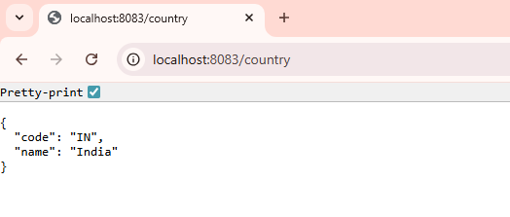

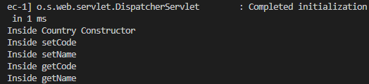

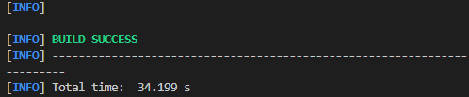

**REST - Get country based on country code**   
  
Write a REST service that returns a specific country based on country code. The country code should be case insensitive.  
  
**Controller**: com.cognizant.spring-learn.controller.CountryController  
**Method Annotation:** @GetMapping("/countries/{code}")  
**Method Name**: getCountry(String code)  
**Method Implemetation**: Invoke countryService.getCountry(code)   
**Service Method:**com.cognizant.spring-learn.service.CountryService.getCountry(String code)  
  
**Service Method Implementation**:

* Get the country code using @PathVariable
* Get country list from country.xml
* Iterate through the country list
* Make a case insensitive matching of country code and return the country.
* Lambda expression can also be used instead of iterating the country list

**Sample Request**: http://localhost:8083/country/in  
  
**Sample Response**:

{

  "code": "IN",

  "name": "India"

}

**FILE STRUCTURE**

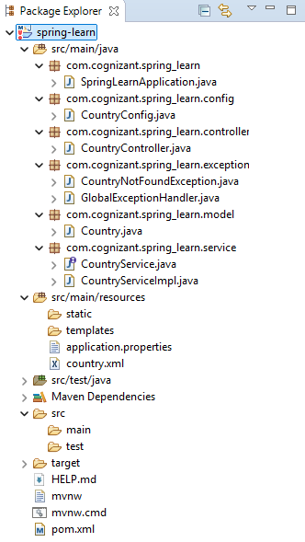

**CODE**

*src\main\java\com\cognizant\spring_learn\controller\CountryController.java*

package com.cognizant.spring_learn.controller;

import com.cognizant.spring_learn.model.Country;

import com.cognizant.spring_learn.service.CountryService;

import org.springframework.beans.factory.annotation.Autowired;

import org.springframework.web.bind.annotation.*;

@RestController

public class CountryController {

    @Autowired

    private CountryService countryService;

    @GetMapping("/countries/{code}")

    public Country getCountry(@PathVariable String code) {

        return countryService.getCountry(code);

    }

}

*src\main\java\com\cognizant\spring_learn\model\Country.java*

package com.cognizant.spring_learn.model;

public class Country {

    private String code;

    private String name;

    public Country() {

    }

    public Country(String code, String name) {

        this.code = code;

        this.name = name;

    }

    public String getCode() {

        return code;

    }

    public void setCode(String code) {

        this.code = code;

    }

    public String getName() {

        return name;

    }

    public void setName(String name) {

        this.name = name;

    }

}

*src\main\java\com\cognizant\spring_learn\config\CountryConfig.java*

package com.cognizant.spring_learn.config;

import com.cognizant.spring_learn.model.Country;

import org.springframework.context.annotation.Bean;

import org.springframework.context.annotation.Configuration;

import org.springframework.context.support.ClassPathXmlApplicationContext;

import java.util.List;

@Configuration

public class CountryConfig {

    @Bean(name = "countryList")

    public List<Country> countryList() {

        ClassPathXmlApplicationContext context = new ClassPathXmlApplicationContext("country.xml");

        return (List<Country>) context.getBean("countryList");

    }

}

*src\main\java\com\cognizant\spring_learn\service\CountryService.java*

package com.cognizant.spring_learn.service;

import com.cognizant.spring_learn.model.Country;

public interface CountryService {

    Country getCountry(String code);

}

*src\main\java\com\cognizant\spring_learn\service\CountryServiceImpl.java*

package com.cognizant.spring_learn.service;

import com.cognizant.spring_learn.model.Country;

import com.cognizant.spring_learn.exception.CountryNotFoundException;

import org.springframework.beans.factory.annotation.Autowired;

import org.springframework.context.ApplicationContext;

import org.springframework.stereotype.Service;

import java.util.List;

@Service

public class CountryServiceImpl implements CountryService {

    @Autowired

    private ApplicationContext context;

    @Override

    public Country getCountry(String code) {

        List<Country> countryList = context.getBean("countryList", List.class);

        return countryList.stream()

                .filter(c -> c.getCode().equalsIgnoreCase(code))

                .findFirst()

                .orElseThrow(() -> new CountryNotFoundException("Country not found: " + code));

    }

}

*src\main\java\com\cognizant\spring_learn\SpringLearnApplication.java*

package com.cognizant.spring_learn;

import org.springframework.boot.SpringApplication;

import org.springframework.boot.autoconfigure.SpringBootApplication;

@SpringBootApplication

public class SpringLearnApplication {

    public static void main(String[] args) {

        SpringApplication.run(SpringLearnApplication.class, args);

    }

}

*src\main\resources\application.properties*

spring.application.name=spring-learn

server.port=8083

*src\main\resources\country.xml*

<?xml version="1.0" encoding="UTF-8"?>

<beans xmlns="http://www.springframework.org/schema/beans"

       xmlns:xsi="http://www.w3.org/2001/XMLSchema-instance"

       xsi:schemaLocation="http://www.springframework.org/schema/beans

       http://www.springframework.org/schema/beans/spring-beans.xsd">

    <bean id="country1" class="com.cognizant.spring_learn.model.Country">

        <property name="code" value="IN" />

        <property name="name" value="India" />

    </bean>

    <bean id="country2" class="com.cognizant.spring_learn.model.Country">

        <property name="code" value="US" />

        <property name="name" value="United States" />

    </bean>

    <bean id="countryList" class="java.util.ArrayList">

        <constructor-arg>

            <list>

                <ref bean="country1" />

                <ref bean="country2" />

            </list>

        </constructor-arg>

    </bean>

</beans>

*pom.xml*

<?xml version="1.0" encoding="UTF-8"?>

<project xmlns="http://maven.apache.org/POM/4.0.0" xmlns:xsi="http://www.w3.org/2001/XMLSchema-instance"

    xsi:schemaLocation="http://maven.apache.org/POM/4.0.0 https://maven.apache.org/xsd/maven-4.0.0.xsd">

    <modelVersion>4.0.0</modelVersion>

    <parent>

        <groupId>org.springframework.boot</groupId>

        <artifactId>spring-boot-starter-parent</artifactId>

        <version>3.5.3</version>

        <relativePath/>

    </parent>

    <groupId>com.cognizant</groupId>

    <artifactId>spring-learn</artifactId>

    <version>0.0.1-SNAPSHOT</version>

    <name>spring-learn</name>

    <description>Demo project for Spring Boot</description>

    <url/>

    <licenses>

        <license/>

    </licenses>

    <developers>

        <developer/>

    </developers>

    <scm>

        <connection/>

        <developerConnection/>

        <tag/>

        <url/>

    </scm>

    <properties>

        <java.version>17</java.version>

    </properties>

    <dependencies>

        <dependency>

            <groupId>org.springframework.boot</groupId>

            <artifactId>spring-boot-starter-web</artifactId>

        </dependency>

        <dependency>

            <groupId>org.springframework.boot</groupId>

            <artifactId>spring-boot-devtools</artifactId>

            <scope>runtime</scope>

            <optional>true</optional>

        </dependency>

        <dependency>

            <groupId>org.springframework.boot</groupId>

            <artifactId>spring-boot-starter-test</artifactId>

            <scope>test</scope>

        </dependency>

    </dependencies>

    <build>

        <plugins>

            <plugin>

                <groupId>org.springframework.boot</groupId>

                <artifactId>spring-boot-maven-plugin</artifactId>

            </plugin>

        </plugins>

    </build>

</project>

**OUTPUT**

